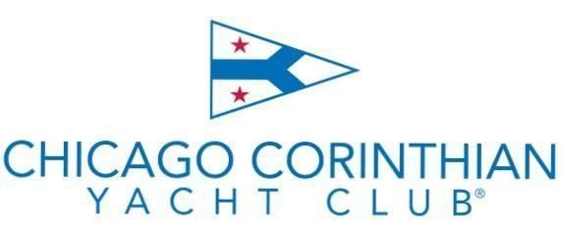

2025
Saturday Fall Frostbite Series Montrose Harbor, Chicago, IL October 4 – November 15

NOTICE OF RACE
- ORGANIZING AUTHORITY
  - Chicago Corinthian Yacht Club is the Organizing Authority for this event.

- RULES
  - The regatta shall be governed by the rules as defined in The Racing Rules of Sailing.

- ELIGIBILITY AND ENTRY
  - The series is open to all boats of the Laser, Vanguard 15, Rhodes 19, Melges15 and 420 sailboats.
  - An eligible boat may enter by submitting the online entry form together with the appropriate fee at racing.corinthian.org.

- FEES
  - Fees are as follows:

Fleet | Registration fee
Laser | $75
V15 | $75
Rhodes 19 | $75
Melges 15 | $75

- SCHEDULE

  - The scheduled time of the first warning signal for all classes is 1000 each race day and there will be no warning signal after 1200.

- SAILING INSTRUCTIONS
  - The sailing instructions will be available no later than the Wednesday prior to the first race day of the series. They will be posted on the CCYC website at r acing.corinthian.org.

- RACING AREA
  - The racing area for all fleets will be in the open waters of Lake Michigan east, northeast or southeast of the entrance of Montrose Harbor or, at the discretion of the race committee, in the waters of Montrose Harbor.

- PENALTY SYSTEM
  - Rule 44.1 is changed so that the Two-Turns Penalty is replaced by the One-Turn Penalty.

- PROTESTS AND REQUESTS FOR REDRESS
  - Routine movement of autonomous marks will not be grounds for redress. This includes minor readjustments, marks returning to station after having been pushed away by a competitor, and collisions with marks that are not actively marks of the course presuming these collisions do not cause damage. This changes RRS 60.1.

- SCORING
  - Nine completed races constitute a series.
  - Once a series has been completed, each boat may exclude her worst scores, one race for every 5 sailed, rounding up, for the entire series.

- BERTHING
  - Competitors for this event are encouraged to contact Westrec Marina (Montrose Harbor) for berthing instructions: (312) 742-7527, montrose@chicagoharbors.com https://www.chicagoharbors.info/harbors/montrose/

- SAFETY REGULATIONS
  - U.S. Coast Guard approved PFDs shall be worn properly secured from the time a boat leaves the dock until she returns to the dock. This changes the Part 4 preamble and rule 40.
  - Unless equipped with an engine, all boats shall have an attached bow line conforming to its class rules. If a class does not have such a rule, the line must be at least 30 feet in length, 1/4 inch in diameter, and properly attached at all times.
  - Boats equipped with daggerboards shall tether them to the boat.
  - Competitors shall not leave Montrose Harbor until the signal boat is on the water.
  - When races are sailed in Montrose Harbor a boat shall not leave Montrose Harbor unless there is no more racing for the day or the boat has withdrawn from racing for the day.
  - A boat that withdraws from a race shall promptly notify the race committee.
  - Due to the COVID-19 pandemic, all participants shall comply with State, Local and Club rules and guidelines.

- CLEANLINESS CCYC is an all-volunteer club, as such all participants and guests are required to clean up any spaces occupied on club grounds and leave them as they found them

- PRIZES
  - Series prizes will be awarded for the top three finishers in each of the fleets at the discretion of the fleet captains and the number of boats sailing the entire series.

- DISCLAIMER OF LIABILITY
  - Competitors participate in the regatta entirely at their own risk. See rule 4, Decision to Race. The Organizing Authority will not accept any liability for material damage or personal injury or death sustained in conjunction with or prior to, during, or after the regatta.

- PHOTOGRAPHY AND VIDEO RIGHTS
  - Competitors give absolute right and permission for any photographs or video footage taken of themselves or their competing boat to be published in any media whatsoever for editorial, commercial purposes, or to be used in press information.

- FURTHER INFORMATION
CCYC Laser Frostbite Chair
Andrea Budano
andreabudano@gmail.com

